PROJECT DOMAIN PHASE
Problem – Solution Fit

Date
Team ID | 6aba09485015c35b9862c9ac
Project Name | FitBuddy – AI Fitness Plan Generator using Gemini Models
Minimum Marks

Problem–Solution Fit
The Problem–Solution Fit for FitBuddy means identifying the challenges users face in creating and maintaining a fitness routine and ensuring that the proposed AI-powered solution effectively addresses those challenges using Gemini models.

Purpose
☐ Create personalized fitness plans based on the user’s goals, fitness level, preferences, and available time.
☐ Help users choose suitable exercises and organize them into a simple and structured workout routine.
☐ Use Gemini models to provide AI-powered fitness guidance and recommendations.
☐ Help users stay consistent by providing suitable workout schedules and progress-tracking support.
☐ Understand user needs and continuously improve the fitness experience through personalized recommendations.

Business Model Canvas
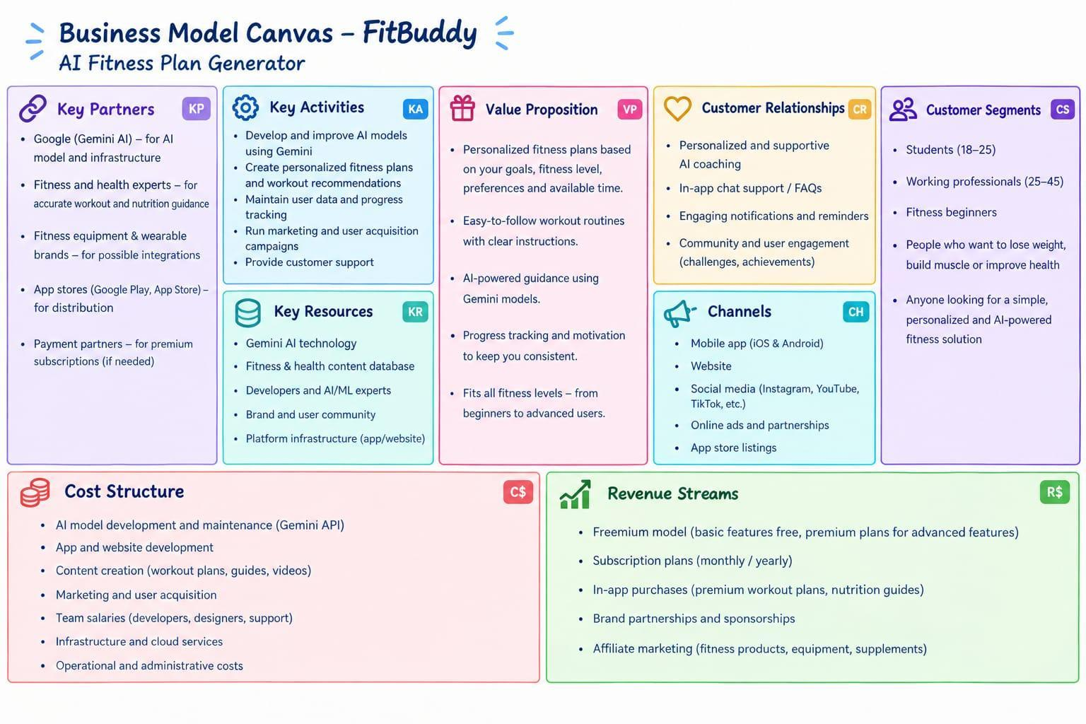

Reference
1.
2.

